The Rip Region Tool

Contents

What is the Rip Tool? 1

How to use the Rip Tool 1

Options for the Rip Region Tool 3

The Opposite Method to the Rip Region Tool 4

The Rip Edge Tool 5

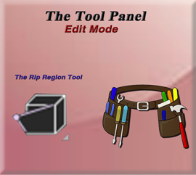

# What is the Rip Tool?

This tool is very simple. Grab some vertices and rip them open. You have a box now you got an open box. You got a sphere “RIP…!” now you got an open sphere. Anything you need to open up, this is the tool for you.

What this tool is doing under the hood is to take a vertex, duplicate it, and now you can move the two of them apart, creating a hole in the mesh. The icon image below sort of spells things out for you in a single image.



# How to use the Rip Tool

Even though this should be a very simple, straight forward tool, right out of the gate. Like every other tool. I will go through the time to demonstrate what this tool is doing.

Take you cube, and bring it into Edit mode.

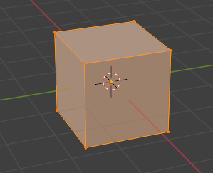

Now select the top two front vertices.

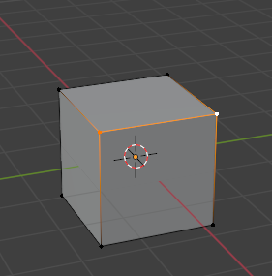

Take your tool, No need to even use the move tool, it comes with the ability to move the ripped face open. And the two tools are packed into one tool.



Just simply tug downward on this circle with your mouse and watch your box open up. How cool is that.

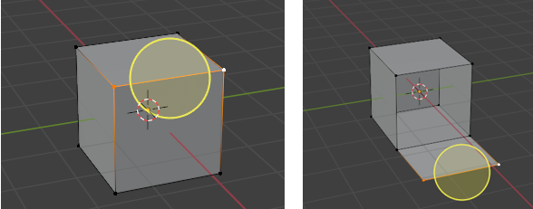

# Options for the Rip Region Tool

You will find one option for this rip region tool at the top of the screen, and that is to Fill it. The options in the Last Operation dialog box deal mostly with how you want the movement of the face, after it is opened to occur.

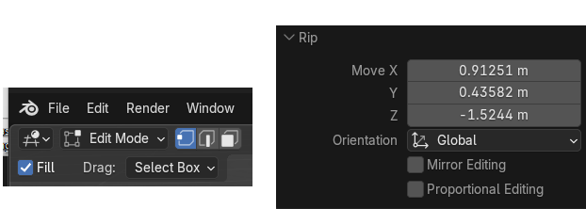

When you select the check box for Fill, you will find that it will fill the face instead of opening it up. This will create new geometry here.

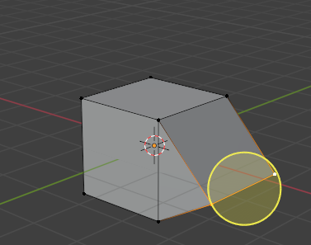

# The Opposite Method to the Rip Region Tool

The Reverse of the Rip Region option is Merge By Distance which you can get to with the M hot key or going here in the top menu. If you move your vertices close together again after ripping you can join them again using this method.

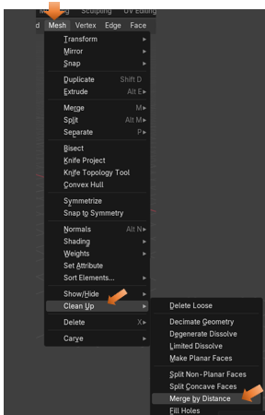

# The Rip Edge Tool

You can get to this tool by opening up the little arrow in the bottom right-hand corner of the Rip Region tool.

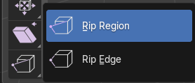

Oh, boy! Did they ever mis - name this tool. That is because it should have been named the Create Vertices Tool. What this tool will do is to duplicate a vertex, and then run it along the mesh.



Now how you work this tool is to select the vertex you want to duplicate, and then pull the tool along the edge to duplicate it.

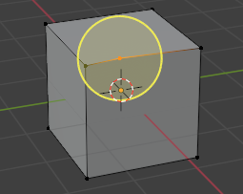

You do not need to pull this circle to move the vertex straight either. You can pull it where ever you want it to be. So, you can kind of mold this object into anything that you want.

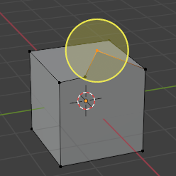

Well, that is about it for this Rip region Tool, and for that matter the entire Tool box in Edit mode. In our next tutorial, we will begin to look at the Sub menu, under the Edit workspace’s main menu, and break that one down for you.